5/17/2020

|  |
| --- |
|  |



|  |  |
| --- | --- |
| NCS Tech Smartans | COVID-19 Contact Tracing and Early Detection System |

SMARTANS COVID CONTACT AND EARLY DETECTION SYSTEM

**Executive Summary**

Tech Smartans is a start-up organization whose vision is to lead the world in building technological innovative solutions.

This software product is designed and created by tech smartans’ development team, to help fight the spread of the novel corona virus which is causing a big problem in the world in general. The software will be used as a means of tracing and getting record of people who might have had contact with the virus.

Included in the system also is an early detection module (symptoms documentation is gotten from NCDC) that will help in determining if the user is test positive to the virus by going through a quick test, with these we get the users information, current location and also the major roads that links to that user location.

**Objectives**

* To prove that technology is a great tool to solve any problem if well optimized
* To flatten the curve of the novel corona virus in the world
* Assist the country in terms of contact tracing

**Introduction**

The Smartans’ COVID-19 contact tracing and early detection software system is basically a web hosted platform developed the Smartans’ group for the purpose of detecting people with the virus in their early stage using the WHO documentation and symptoms analysis, tracing them to their current location by the federal medical bodies in the country thereby doing the necessary to the person and that community.

These software system is capable of highlighting hot zones or territory where the virus has it highest number of confirmed cases based on our system diagnosis and also cold zones where there is little or low reported cases.

**Review of Existing Related Systems**

From our recent research we learnt there is already an existing system operating similarly as ours. It is called the **stopcorona.app** it is a free database for COVID-19 hotspot.

And we are working towards implementing that structure in our system as it will help our medical bodies in the country a lot in terms of contact tracing and early detection of the virus in the country.

**Methods/Tools**

Our system basically depends on some API’s which are used to fetch users accurate location and analyze them.

We are also making use of GIS (**Geographic Information System**) on our admin end in order to spot out both cold and hot zones and also for visualization by fetching user location data from our database which had been previously saved to our database.

For early detection we created a module that will analyze user data input from our online form and then convert it to a response that is well understandable by our system and thereby use that response to diagnose the report and give submit user health status based on information provided by the user,

Currently we are also working towards avoiding data duplication and database flooding by numerous submission of data by users due to misuse of the system by users.

**Implementation**

Our system can be implemented majorly in the health sector and other related agencies working on the COVID-19 pandemic in the country as a system for tackling the spread of corona virus.

Our system is been deployed as a web hosted system that is user data is not in any-way stored offline because on any data loss and security.

As stated previously we are making use of the GIS as a means to know where the virus hot zone and cold zone are and how to contain the virus within that territory

**Current Stage**

Currently we are still working on the full implementation of the GIS into our system and also working on delivering a good and fascinating UI/UX for easy use of our system by the users.

We have designed the module that will help us to analyze user data inputs and give report on user health status depending on what the user provided.

**Economic Viability**

In the area of the economic viability of our system, it is:

1. Reduce the cost of house to house contact tracing currently implemented in Lagos state in terms of finance.
2. Save the citizen from further exposure to the virus all in the name of house to house contact tracing and inspection.
3. Save the stress and time for people to report to the hospital if they are actually having or showing the symptoms of the virus
4. Reduce wastage of resources and funds allocated to contact tracing and early detection of the virus.
5. Government officials will no longer need to expose themselves to the virus by doing physical testing. After user using our system and tested positive by our system then Government medical practitioners will also conduct the physical test for verification if the need arise.

**Process**

1. **User End**
2. Visit project **url**

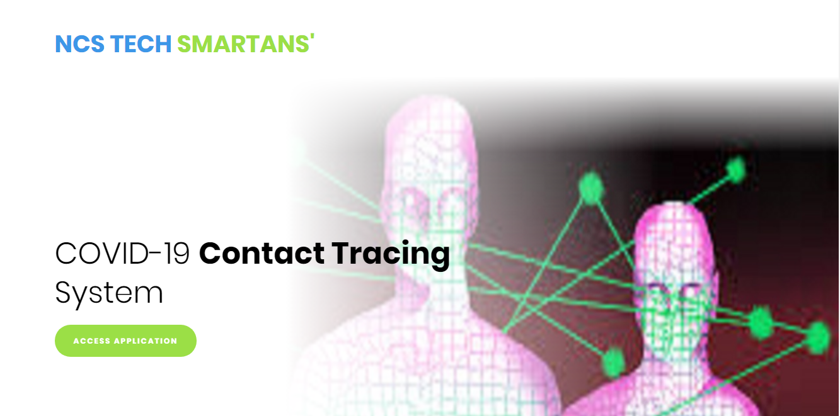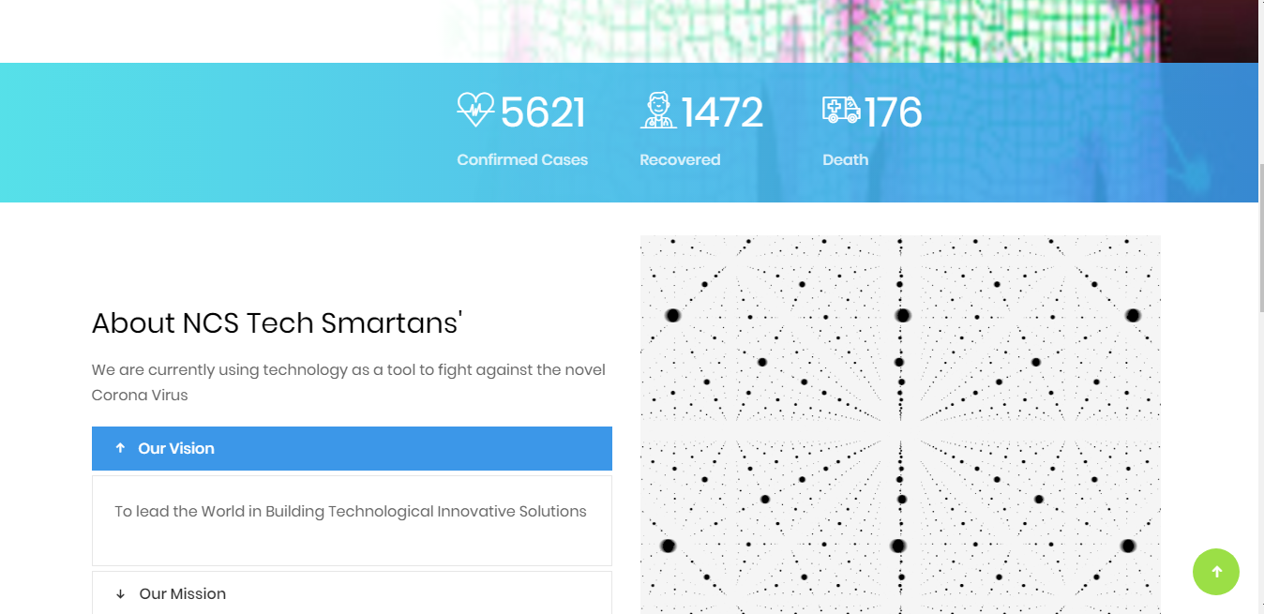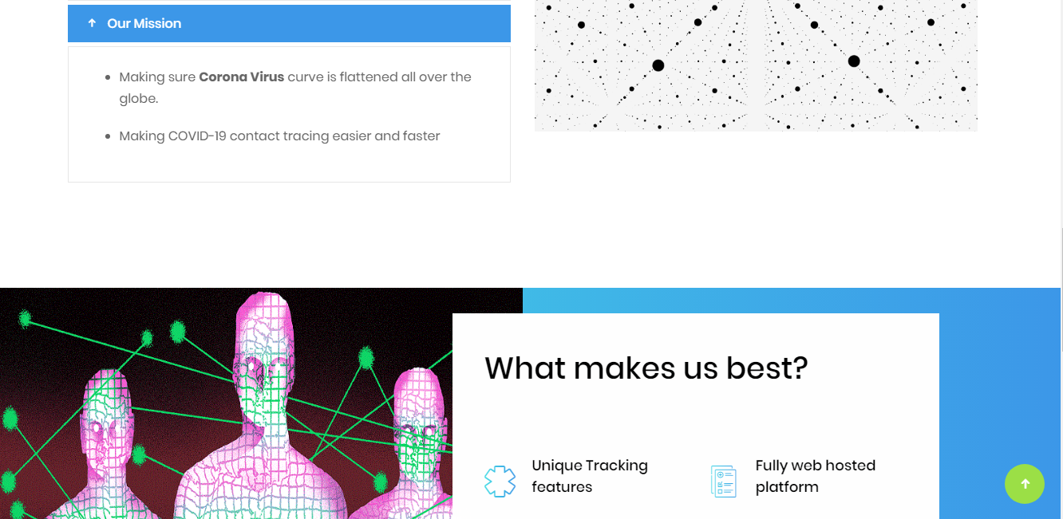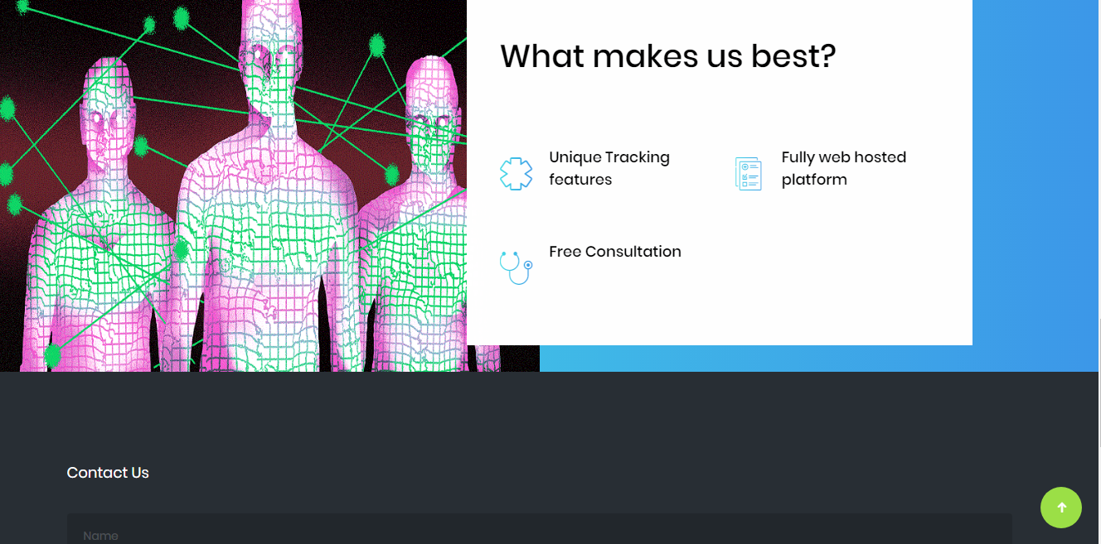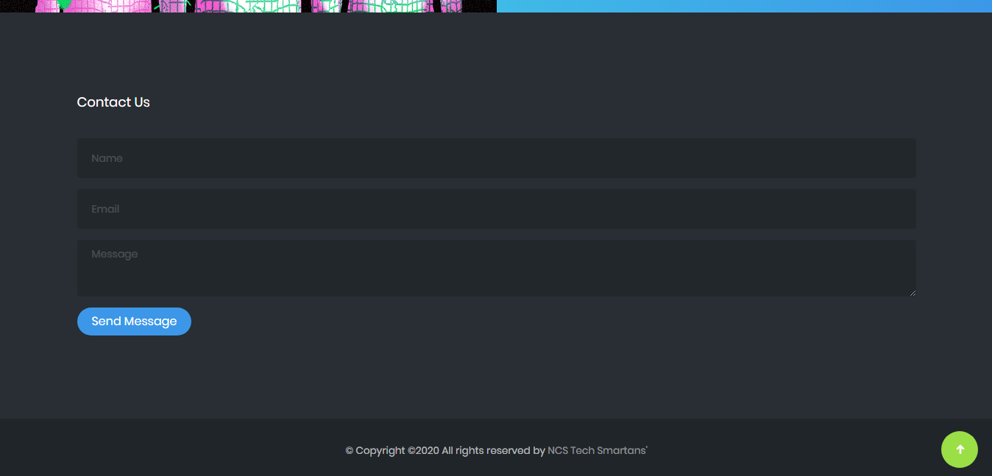

1. Click on Access application to further

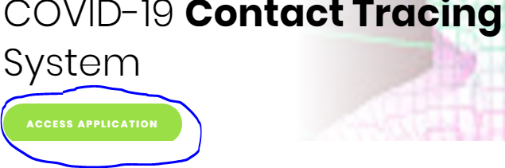

1. Choose whether to grant the site permission to access your device location

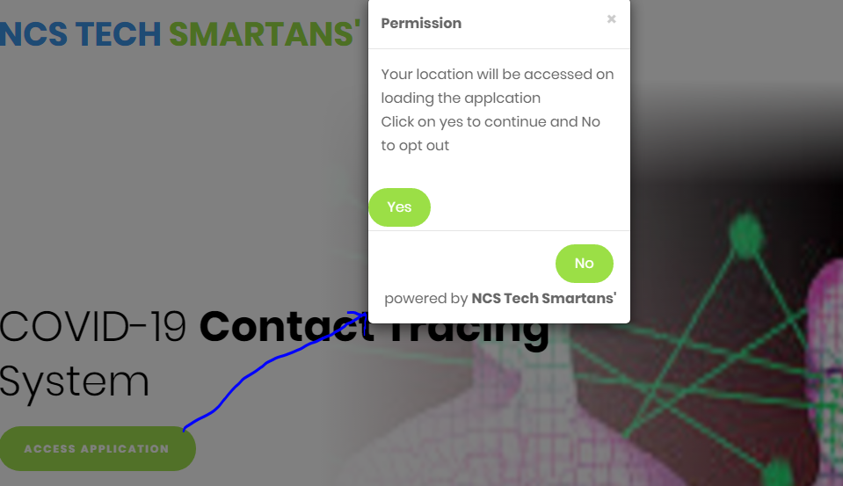

1. Carry out short test and click on done on completion

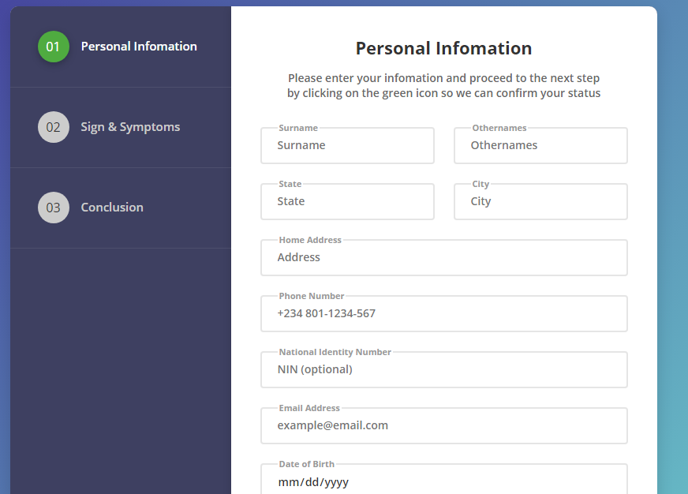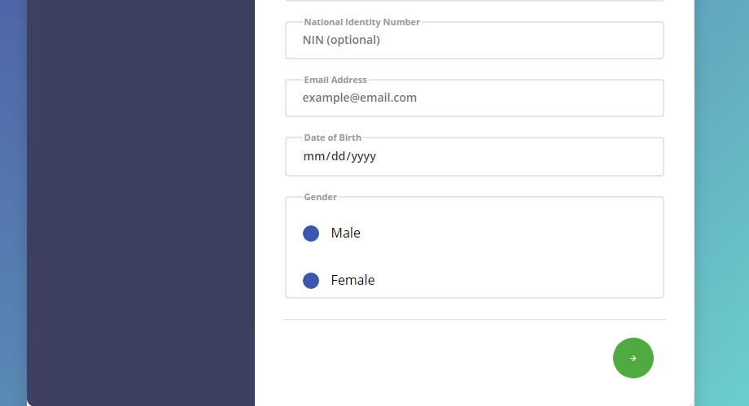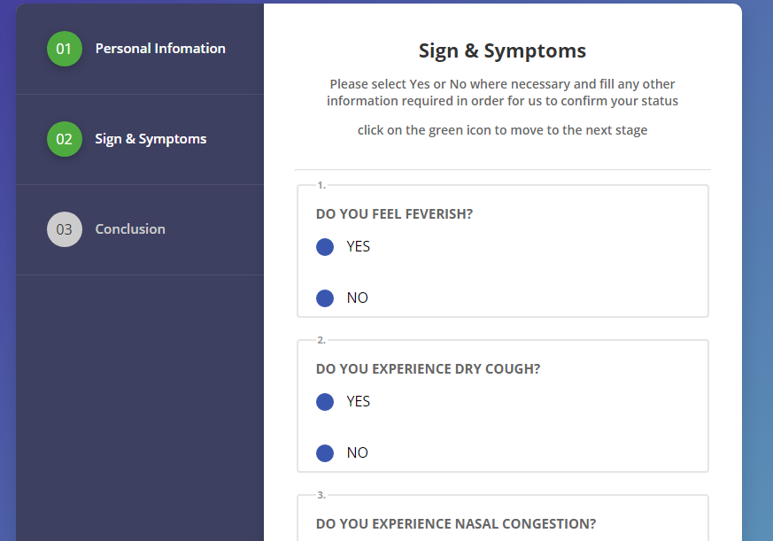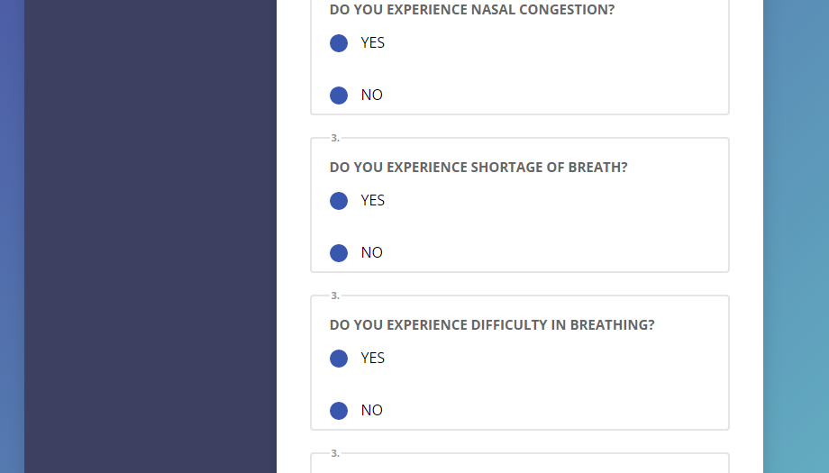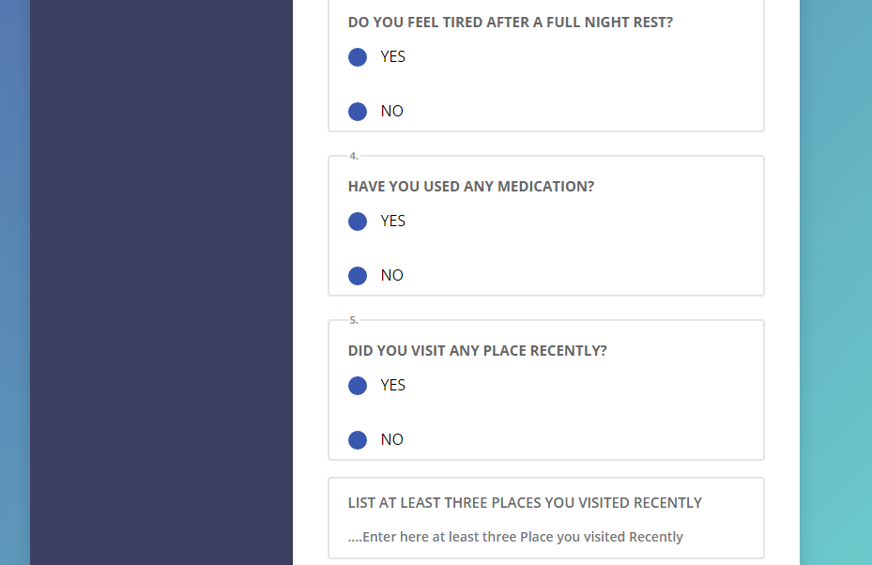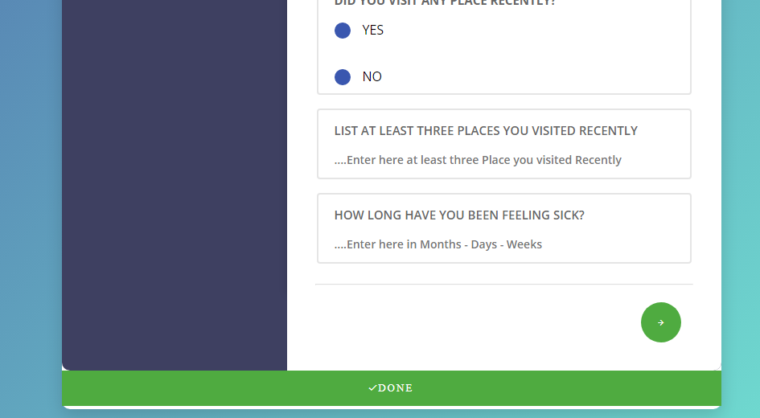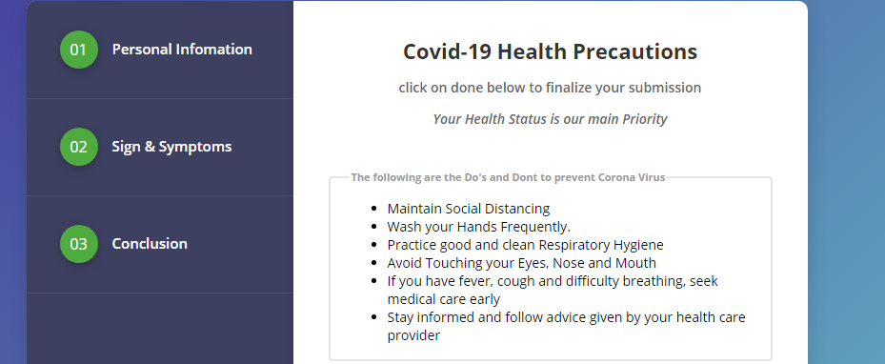

1. **Admin End**
2. Login to access admin panel

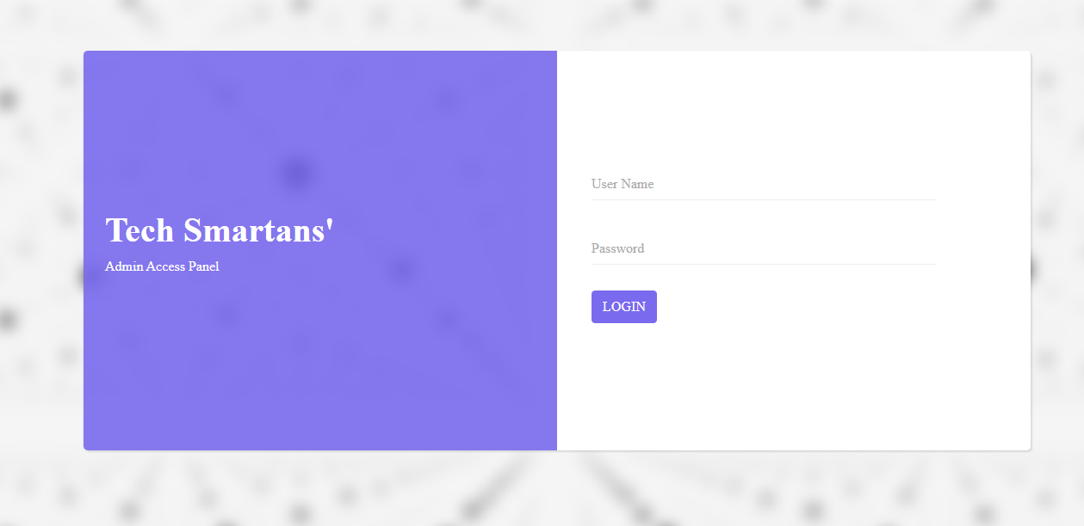

1. View total number of submitted data

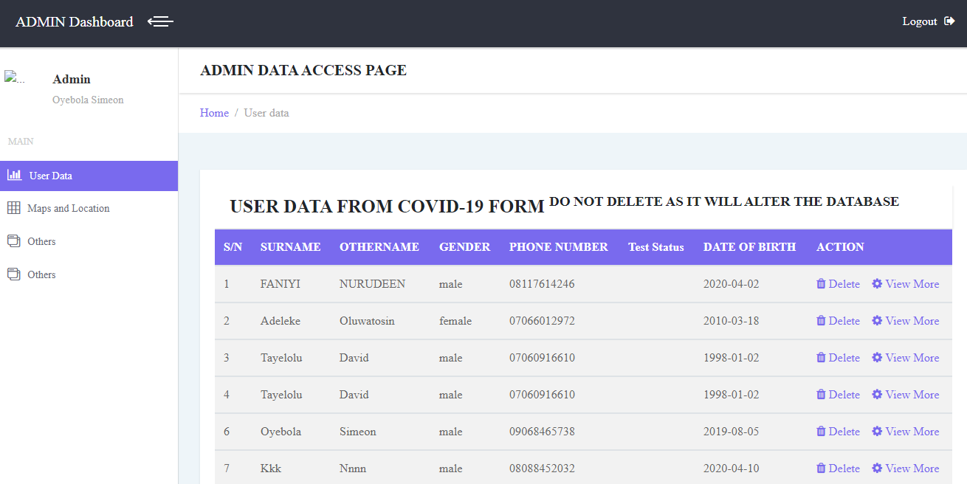

1. View individual data and click on view more to see other data



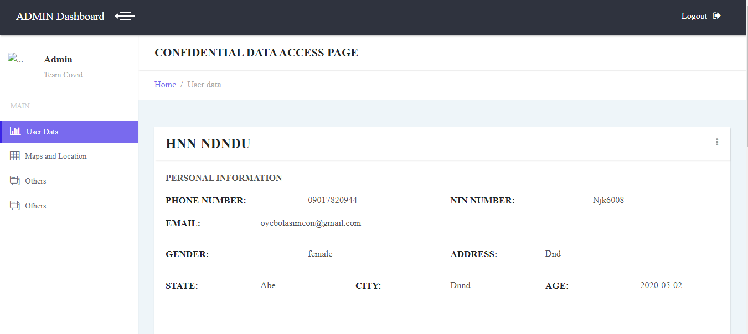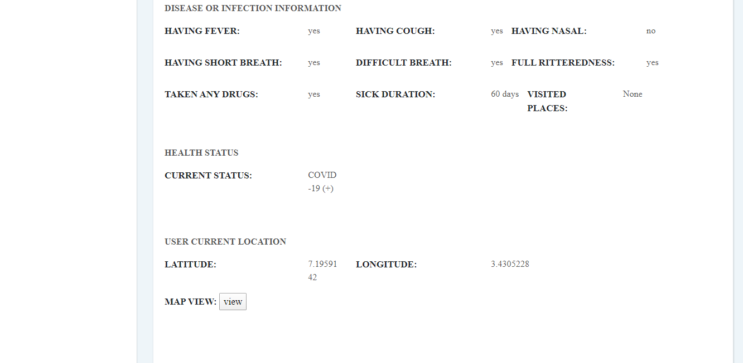

1. View map showing major roads and user current location, admin can zoom to have a clear view

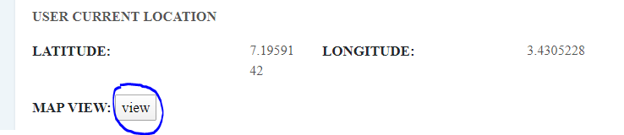

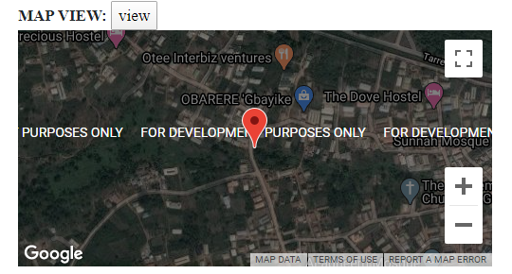

1. Generate confidential report as pdf for further verification

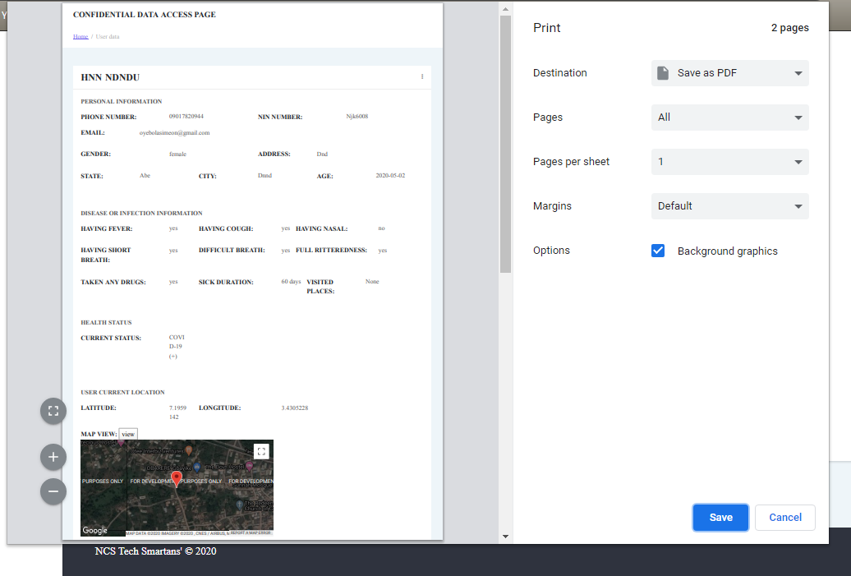

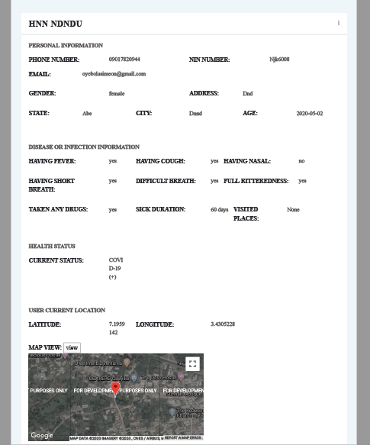

1. **Logic**

Fetch visitor longitude and latitude value

Return location value and send to database

Send form response

Send response to database

Generate report and print

Analyze form response and provide health status report

**Conclusion**

In conclusion, the general aim of this project is to reduce the spread of the corona virus and also contain the virus using technology as a tool.

Our system is still in the **Alpha phase** of development currently, we are working towards moving it to the **Beta** **phase** of development as time goes on.

©NCS Tech smartans’ 2020